

TA (Textual Analysis) for UML USE CASE Diagram MODEL
for Movie Company System
A1: User

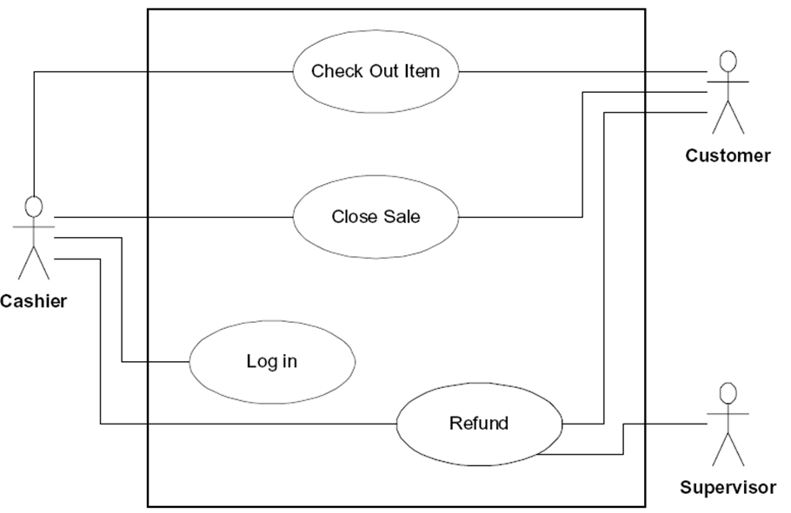

The Movie Company has the following affiliated Artists (maximum 10):

“Miles Davis”, with 3 Discs:
Disc 1: Title “Miles Ahead” with Track “Miles Ahead” that is 3.34 minutes
Disc 2: Title “Tutu with Tracks: “Tutu”, 4.56, “Portia”, 3.34, “Tomaas”, 3.56
Disc 3: Title “Kind of Blue” with Tracks “So What”, 4.54, “Freddie Freeloader, 5.25, “Blue in Green”, 2.56
“John Coltrane”, with 1 Disc:
Disc 1: Title “Blue Train” with Blue Train” that is 5.15 minutes; “Moments Notice”, 5.52, “Locomotion”, 6.18

The Movie Company wants to keep a catalog of its artists and their discs (maximum 30). Artists have a name. The Movie Company can add an artist or get a listing of all its artists.
UC1: UCAddArtist
UC2: UCListArtists
Each artist produces music Discs. A Disc is associated with an Artist. A Disc is cataloged with a disc catalogNumber. The Movie Company can add a disc or get a listing of all its discs.
UC3: UCAddDisc
UC4: UCListDiscs
A Disc has a number of Tracks. The Track has a title and a duration time. A Disc has a catalogNumber , a title, the number of tracks. The Movie Company can add a track or get a listing of all tracks for a given disc.
UC5: UCAddTrack
UC6: UCListTracksForDiscs
UC7: UCRestoreCatalog
UC8: UCSaveCatalog
UCAddArtist
UCListArtists
UCAddDisc
UCListDiscs
UCAddTrack
UCListTracksForDisk
Controller

UC 1

UC2

UC3

UC4

UC5

UC6

UC7

UC8

UCRestoreCatalog
UCSaveCatalog
A1: User

UC1 UCAddArtist Description
Name: | UCAddArtist
Actor: | User
Description: | This use case describes the process used by User to Add another Artist
Successful Completion: | User requests Adding Artist by artistName  - Movie Company System checks to see if not already there and there is room in the artists array  - Artist with artistName is added at the end of the artists array and successful message is sent to the User
Alternative: | User requests Adding Artist by artistName  - Movie Company System checks to see if not already in the artists array and there is no room  - If artistName either ALREADY present or NO MORE ROOM MAX_ARTISTS Artist with artistName is NOT added and UNsuccessful message is sent to the User
Pre-Condition: | User requests Add Artist
Post-Condition: | Artist with artistName Added successfully or UNsuccessfully
Assumptions: | None

UC2 UCListArtists Description
Name: | UCListArtists
Actor: | User
Description: | This use case describes the process used by User to List all Artists
Successful Completion: | User requests Listing Artists  - Movie Company System displays all the Artists by traversing the artists array
Alternative:
Pre-Condition: | User requests List Artists
Post-Condition: | Artists displayed
Assumptions: | None

UC3 UCAddDisc Description
Name: | UCAddDisc
Actor: | User
Description: | This use case describes the process used by User to Add another Disc for a particular artistName
Successful Completion: | User requests Adding Disc to artistName  - Movie Company System prompts for discCatalogNumber  - Movie Company System prompts for disc  - Disc discCatalogNumber , disc is Added to the disks array and successful message is sent to the User
Alternative: | User requests Adding Disc to artistName  - Movie Company System prompts for discCatalogNumber  - Movie Company System prompts for disc  - Movie Company System checks to see if not already the disks array and there is room in the disks array  - If disc either ALREADY present or NO MORE ROOM MAX_DISCS Disc disc is NOT added and UNsuccessful message is sent to the User
Pre-Condition: | User requests Add Disc
Post-Condition: | Disc discCatalogNumber, disc Added to the disks array successfully or UNsuccessfully
Assumptions: | None

UC4 UCListDiscs Description
Name: | UCListDiscs
Actor: | User
Description: | This use case describes the process used by User to List all Discs
Successful Completion: | User requests Listing Discs  - Movie Company System displays all the Discs in the disks array, discCatalogNumber, title, artistName
Alternative:
Pre-Condition: | User requests List Discs
Post-Condition: | Discs displayed
Assumptions: | None
UC5 UCAddTrack Description
Name: | UCAddTrack
Actor: | User
Description: | This use case describes the process used by User to Add another Track trackTitle, time for a particular discCatalogNumber
Successful Completion: | User requests Adding Track to Disc discCatalogNumber  - Movie Company System prompts for trackTitle  - Movie Company System prompts for time  - Track trackTitle, time is Added to Disc discCatalogNumber and successful message is sent to the User
Alternative: | User requests Adding Track to Disc discCatalogNumber  - Movie Company System prompts for trackTitle  - Movie Company System prompts for time  - Movie Company System checks to see if not already there and there is room  - If trackTitle either ALREADY present or NO MORE ROOM MAX_TRACKS Track trackTitle is NOT added and UNsuccessful message is sent to the User
Pre-Condition: | User requests Add Track
Post-Condition: | Track trackTitle, time Added to Disc discCatalogNumber successfully or UNsuccessfully
Assumptions: | None

UC6 UCListTracksForDisc Description
Name: | UCListTracksForDisc
Actor: | User
Description: | This use case describes the process used by User to List all Tracks title for a Disc discCatalogNumber
Successful Completion: | User requests Listing Discs  - Movie Company System displays all the Tracks title for Disc discCatalogNumber
Alternative:
Pre-Condition: | User requests List Tracks for Disc
Post-Condition: | Tracks for Disc displayed
Assumptions: | None

UC7 UCRestoreCatalog Description

Name: | UCRestoreCatalog
Actor: | None
Description: | This use case describes the process of reading the catalog from a data file (Input). It is called automatically when the Movie Company System starts running
Successful Completion: | - Opens “Catalog.txt” file and reads the catalog
Alternative:
Pre-Condition: | None
Post-Condition: | The catalog resides in the Movie Company System memory.
Assumptions: | File “Catalog.txt” was read successfully

UC8 UCSaveCatalog Description

Name: | UCSaveCatalog
Actor: | None
Description: | This use case describes the process of writing the catalog from Movie Company System memory to data file “Catalog.txt” (Output). It is called automatically before the Movie Company System exits
Successful Completion: | - Opens “Catalog.txt” file and write the catalog
Alternative:
Pre-Condition: | The catalog resides in the Movie Company System memory.
Post-Condition: | The catalog resides in the “Catalog.txt” file.
Assumptions: | File “Catalog.txt” was opened for write successfully

